Component 1
Media Products: Industries and Audiences

Independent Study

A Level Film Industry Case Study:
I, Daniel Blake (2016)

Your Name:……………Nadia Bilek……………………….

Key Terms: Research the following key terms online and in the text book chapter, it is essential you remember these key words for the exam.

Independent Film | Any character-driven film that is made outside the traditional Hollywood film system with a very small budget and keeps the artist/filmmaker’s original vision intact without corporate corruption.
Mainstream Film | Mainstream movies can be defined as movies that cost much to make and are created for profit. Can be defined as Hollywood films because they make up the majority of the most widely distributed films in the world.
Media Conglomeration | Companies that own large numbers of companies in various mass media such as television, radio, publishing, movies and the internet. By definition it is a large company that consists of divisions of seemingly unrelated businesses e.g. Disney
British Film Institute | The British Film Institute (BFI) is a film and charitable organisation which promotes and preserves filmmaking and television in the United Kingdom. The BFI uses lottery funds to encourage film production, distribution, and education.
Digital Convergence | The term digital convergence means the ability to view the same multimedia content from different types devices.
Production Values | Production values are the lighting, sound, scenery and props used to improve a film or play.
Vertical Integration | The combination in one firm of two or more stages of production normally operated by separate firms.
Horizontal Integration | Horizontal integration involves the combination of two business operating in the same industry and at the same stage of the supply chain.
Social Realist Genre | Refers to films that give an indication of what life is really like. They often explore wider social issues through the creation of emotional and personal stories.
Grassroots Campaign | A marketing strategy that targets a smaller, niche group, often a particular community, in the hope that they will spread the word to a broader audience.
Disruptive Display Advertising | Advertising content that appears in unexpected places, for example in the plug of a daily newspaper, which arrests attention because it challenges expectations of what is typical.

Production Context:

(Textbook Page 110 - 111)

What are 4 characteristics of an Independent Film?
- Is usually made outside this financial and artistic control of a major film company
- Is defined by a distinguishable style often related to the genre, the social message or the filmmaker.
- Is made by smaller film companies or individual producers with a low budget. This is often evident through the absence of high-profile stars and the use of everyday settings.
- May have a different distribution model, for example viral and word-of-mouth marketing, screening at smaller independent cinemas and a shorter run.

What are the key indicators of a mainstream film like Straight Outta Compton?
- High production values
- Elements that can be used in the marketing of the film and become part of the films branding for example the soundtrack and logo.
- High-profile stars often associated with the genre
- A narrative that can be easily marketed and is indicative of the genre.
- Visually attractive elements, for example special effects
- Characters that are stereotypical of the genre including key, recognizable protagonists.

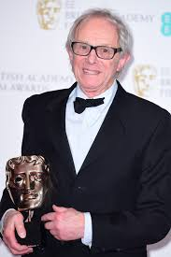
Who is Ken Loach? What else has he directed?
(Google Search)
- English filmmaker and Director of I, Daniel Blake.
- Ken Loach’s other work has addressed similar issues (Cathy Come Home, Raining Stones) and he is a social campaigner, known for his socialist political views.
- He helps maintain his profound audience by constantly churning out important articles with societal messages for the good of the world.
- Loach’s work whilst having broad appeal sits firmly within the niche of social realism and candidates may discuss the extent to which the fans of his work are pre-sold based on his name alone.

What type of production was I, Daniel Blake? E.g How was it financed/Funded?
(A Level Fact Sheet)
- I, Daniel Blake is an independent social realist film directed by renowned filmmaker Ken Loach (Kes, Raining Stones, Sweet Sixteen etc.).
- A UK/French co-production, it received funding from the BFI and BBC Films.
- It became Ken Loach’s largest grossing film at the box office (taking over $8 million), was highly critically acclaimed and generated much debate due to the contemporary social and political issues addressed in the film.
- I, Daniel Blake was exhibited at many film festivals, won the Palme d’Or at Cannes, and was nominated for many awards including several BAFTAs.
- I, Daniel Blake is a low budget social realist film, funded by the BFI and BBC. It was filmed largely on location (hospital, job center etc.), features lesser known actors and does not rely on special effects.

How much money did the film make?
(A Level Fact Sheet)
- $15.8 million


What was the critical response to the film? Reviews, Awards?
(A Level Fact Sheet)
- I, Daniel Blake was exhibited at many film festivals, won the Palme d’Or at Cannes, and was nominated for many awards including several BAFTAs.
- Some Right-wing viewers thought that it was an exaggeration and that reality was very different, also questioning the legitimacy of the accounts the job center staff gave them.
- Left wing liberal politicians were in favour of the film, Jeremy Corbyn came to the Premier and recommended the film to whoever would listen.

Social and Political Context:

What issues does the film address? What is it about?
(A Level Fact Sheet)
- I, Daniel Blake addresses contemporary British social issues such as poverty, the welfare system and the Work Capability Assessment.
- The film portrays a group of traditionally underrepresented characters in Newcastle struggling in poverty to gain benefits and support.
- I, Daniel Blake conveys a clear left-wing political message and criticises specific government policies.
I, Daniel Blake was exhibited at many film festivals, won the Palme d’Or at Cannes, and was nominated for many awards including several BAFTAs.

Does the film provide a left or right wing political message?
(A Level Fact Sheet)
- Left wing
government policies. Consideration of the wider economic context and concept of “austerity” might be useful in exploring how changes to benefit policy had been justified.
What is the British Film Institute and how does it serve the film industry in the UK? (Google Search)
- The British Film Institute (BFI) is the lead organisation for film in the UK and use Lottery funds to support film production, distribution, education and audience development.

Why might Ken Loach and his producers be less concerned with this type of film becoming a big box office success? (Your own interpretation)
Their aim was to have a more political message and influence on their audience, they even sold discounted tickets so that the people who were affected by the system could afford to see the film.
Being a big box office success would have helped spread the message but it may have spread to those who don’t follow the same values therefore wasting marketing expences.
How was I, Daniel Blake marketed?

Read pages 112 – 113 of the textbook chapter.

- Which company distributed the film?

eOne

- What other films have they distributed?

The BFG and The Girl On The Train

3. Where did the film premiere take place?

Newcastle

4. Which Newspaper corporation did eOne collaborate with in marketing the film?

Trinity Mirror

5. What is the political stance of Trinity Mirror and it’s flagship newspaper The Daily Mirror?

Labour- left wing

6. How was disruptive-display advertising used?

They had an editorial campaign that allowed them to change the typical masthead and front cover of the Daily Mirror to catch attention

7. What impact did it have?

59% reader remembered seeing it and 57% said it made them want to see the film

Production, Distribution and Circulation.
Watch the trailer for I, Daniel Blake.
(YouTube)

What type of locations does the film take place in?
How might this suggest the film has a low budget?
Job Centre, Hospital, Food Bank, Home, Library

There are no places with expensive looking furnishing or glamorous landscapes, all the places were filmed in real location

Why would this kind of social realist film benefit from casting unknown actors?
As the story will not be distracted with the A list cast, derailing the meaning of the story. Also it is hard to be annoyed by the fact that a multimillionaire is playing a man on benefits

Watch the trailer again, this time focus on the trailer’s aim to make audiences interested in the film:

How does the trailer persuade audiences to go and see the film?
It creates and tense and emotive scene that could tug at the heartstrings of the audience and also cause them to be likely to see the film. The use of a diverse cast also would appeal to a wider audience.
The reference to their awards also gives a stamp of credibility to the film.

Now, check your answers on page 113 of the textbook.

Use your own knowledge and experience of film marketing and the resources to answer the following questions.

- Where and how are films and their marketing most likely to be consumed by audiences?
- Where might an older audience see the trailer or poster?
In the Daily Mirror editorial or on a bus stop
- Where might a younger audience access marketing for the film?
On the website or social media
Contemporary Forms of Advertising
Look at the Official Website for I, Daniel Blake
http://www.ifcfilms.com/films/i-daniel-blake
What links to social media does the website offer?
Links to the trailer on YouTube, Twitter and Facebook links

Traditional Advertising: Look at the poster for the film
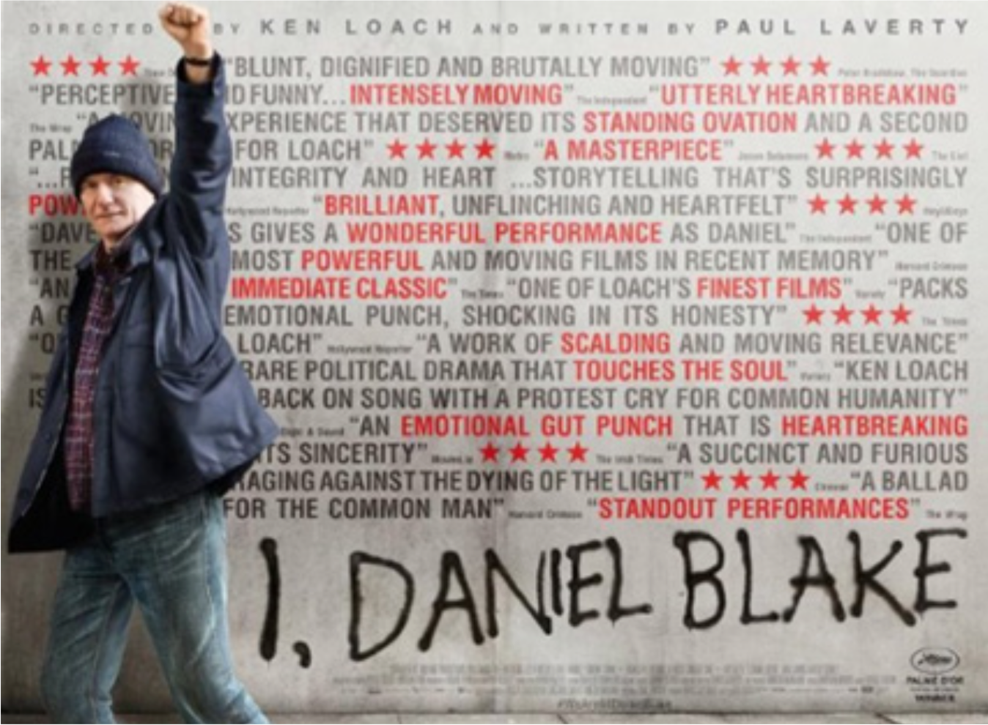
What methods does the poster use to promote the film?

- Reviews
- Directors name
- Main character
- Title
- Production logos

What is meant by word of mouth advertising? (Online)
- Word-of-mouth advertising means that your customers tell other people about your business and their experience using your company.

How has this consumption changed/been impacted by the ease of access of online and social media? (Your opinion)
- Regulation is harder so companies like OFCOM are more liberal.
- It is easier to find out about the production of the film
- It is easier to discover more about political stances in films and share ideas with others.

Are audiences now more likely to seek out marketing (e.g. new trailers) online as active consumers? (Your opinion)
Yes as it will also lead them to extra information and as it is so easy to find the trailer initially so if you are interested with the storyline it is easy to find
In which other countries was the film released? (Online)
France, Italy, New Zealand, Poland, Switzerland, Bosnia and Herzegovina, Canada, Spain, Finland, USA, South Korea, Brazil, Ireland, Belgium etc

Read the information About the BFI 2022 strategy.
https://www.bfi.org.uk/2022/
Why would the BFI fund I, Daniel Blake?
They would fund it because of the fact they want to create a variety of content that appeals to niches in the UK also they are aware of the lack of funding more political content is given.
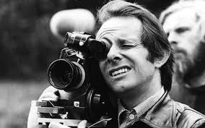
The effect of individual producers on media industries: Ken Loach
Watch the trailers for these films directed by Loach.

The Wind that Shakes the Barley (2007)

The Angels’ Share (2013)

Jimmy’s Hall (2015)

What similarities do these films share with I, Daniel Blake?
- They are also low budget
- They show freedom of speech and opposing political parties
- Some also won at the Palm D’Or
- Show defiance and equality
Read textbook page 114
Consider the extent to which I, Daniel Blake can be described as a
mainstream product. Loach is a well- known and successful figure in
the UK and Europe. To what extent do you think his work is
mainstream?
I don’t think he is mainstream as more mainstream films carry a more fantasy element or a glamorous storyline. Loach’s credibility does offer a more secure standing from a financial POV but the audience and staff for the film are still in a niche market.
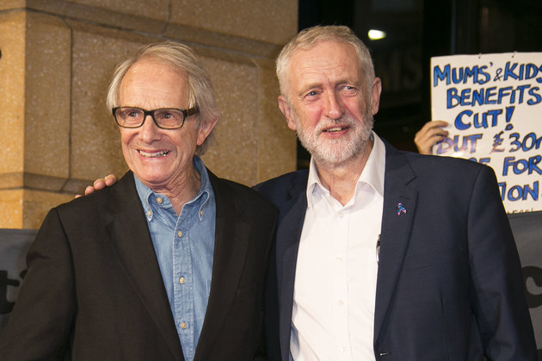
Which political party does he support? Has he been involved in any forms of
political activism?
- He is liberal and supports Labour.
- At the Labour Party conference in September 2017, Loach said he had been going to Labour Party, trade union and left-wing meetings for over 50 years and had never heard anti-Semitic or racist remarks, although such views certainly existed in society.

Does the fact he is challenging governmental policy mean he is also
challenging mainstream opinions? What do you think?
I think so to a certain extent, his liberal views show him defying the government and becoming a mouthpiece and pied piper to the people who need to hear what he preaches. His films are more political though so I do not think he challenges all mainstream opinions just the majorly political and problematic ones.
Section B: Understanding Media Industries and Audiences
Practice exam questions: This should take you no more than 15 minutes, write your responses in the spaces provided.

- (a) Briefly explain what is meant by distribution. [2]

The sharing of content to a wide audience, this can be done digitally or physically. In the case of I, Daniel Blake it was distributed in cinemas and then sold on DVD and also available on certain streaming sites for a period of time.
(b) How have recent technological changes had an impact on
the production and distribution of films? [10]

Technological changes have impacted production and distribution due to the ease of the way we can access media. No longer do we have to go out and physically buy or watch a movie in a cinema, but we can stream it online or share with others remotely. This technological change had benefitted the audiences but maybe lessens the experience of films, due to the ease of watching one we tend to bulk watch or binge films and series therefore not appreciating the effort and time that is taken into them, whereas in a cinema you may be able to appreciate the intricacy and huge budget of a film.
In addition the widespread actions of technology limit the use of regulation in the industry, Livingstone and Lunt state in their regulation theory that as technology allows you to stream and access movies so easily that the OFCOM and other regulation parties now hold little to no affect on you. Also as you may watch films from home rather than at the cinema there is no one to assess if you are the suitable audience for the film, this could lead to more dissatisfied younger audiences and the mistreatment of free speech, giving the audience room to slander the ratings they’ve ignored.

(c) What is a media conglomerate? [1]

A media conglomerate is a company that owns a few/lot of smaller subsidiary companies, they can either be vertically or horizontally integrated or not linked at all. A huge company like Disney uses relational vertical integration to ease the ability to make films, reducing turnover time and expenditure.

